Judicial error and institutional design
Peter Lewisch
- Introduction and Background
- Judges have to decide legal questions not in a vacuum, but in a contextual environment: the sun shines, the home football team has won the previous day and brakfast was excellent: Any influence on decision making to be expected? Yes, but…
- Tons of literature on behavioural anomalies,
- not too many policy proposals, and if so, on rather isolated issues.
- Why?
- Does the literature rather convey insights about isolated phenomena,
with which individuals can well cope by (rational) adaption?
- Or is it that these phenomena describe general properties of human decision making that are omni-present and cannot be avoided anyhow?
- Or does the policy discussion disregard the „big themes“?
- A mixture of everything, but: subject matter is extremely relevant.
- Subject of this talk: errors in legal decision making and institutional design.
- How shall we structure our procedure (on the „rule level“) to avoid biased decision making?

- Development of the literature
- Identification of Biases
- Acknowledgment of Biases in Legal Decision Making („unincentivized paper/pencil experiments“), Kahneman/Tversky …
- Acknowledgement of Biases in Jury Decision Making (also empirical); vast literature.
- Acknowledgement of Biases in decision making of professional judges (Rachlinski).

- Standard („technical“) biases: „One-dimensional“ („linear“) decision making „errors“
- Anchoring
- Hindsight-Bias
- Priming
- Context-dependent choices, etc.
Interesting as such, but not of concern for basic institutional choices on procedure.

- Fundamental („basic“) biases in (legal) decision making

- Principles of (legal) decision making
- Types of basic biases
- Confirmation Bias,
- Perspective Bias,
- Coherence Shifts,
- „Consecutive Bias“: Path-dependent, dynamic interpretation of information.
- Characteristics of pertinent literature with regard to these biases
- Tendency to over-categorize („labelling bias“),
- Concerns often complex phenomena that „materialize“ in different directions („framing effects“),
- Based on difference between „news“ and „information“,
- the attaching of meaning to objects („creation of reality),
- and the „constructivist school of psychology“ (Watzlawick)
- very powerful,
- at the heart of human information processing & decision making;
- immediate and profound legal/procedural impact.

B. Concrete Biases
- Confirmation Bias
- Decision making in accordance with one´s own perceptions/assumptions /hypotheses/intuitions:
- Search for information,
- processing of information,
- decision making proper.
- Extremely high relevance for arrangement of procedural rules:
- In continental legal system with active judge, judge knows and must know the file before the oral trial,
- strong hypotheses built on contents of file (and personal interpretations),
difficult to shaken hypotheses of judge.
- Institutional design:
- Conceptual distinction between „judge of procedure“ („referee“ = managest he procedure, but does not decide on the merits) and „judge of decision“ (judge taking decision on the guilt question, not involved in the management of the case),
- In principle, either could be professional judges, but
- typically, „judges of decisions“ are lay judges.
- Explains jury system.
- Story model? Is jury system plagued with identical problem?
- No. Only with a similar problem.
- True, human beings are not a computer which first gather all available information and then („press button“) process it.
- Instead, gradual processing of information, and hypotheses are built and adapted constantly as the procedure develops.
- First piece of evidence provides frame, through which subsequent evidence is seen and interpreted (with or without „story“).
- In principle, unavoidable. Less acute, because hyotheses are not so stable as if built beforehand, based on entire file. True for any (professional or lay) decision maker.
- See experiment presented here, paper by Mischkowski/Glöckner/Lewisch.

- Perspective Bias
- News does not have informative value by itself.
- Individuals „create“ a reality by attaching a certain meaning to facts („framing“).
- Assignment of a specific task forces individual to make decision in the light of this perspective:
- Debbie-Experiment by Dan Simon:
- Fictional cheating scenario,
- Assessment of the facts of the case and of character of suspected student based on „prosecutorial“ perspective.
- Spill-over effects to next task.
- This paper describes findings from two studies that tested the adversarial role assignment on the objectivity of evaluations of a person’s guilt. The first showed that adversarial assignments polarize people’s views of the case towards the corresponding assignments, while non-adversarial assignments result in judgments somewhere in the middle. The second found that this distortion is mediated by a sense of partisanship. Together this suggests that the adversarial process bears an adverse effect on law enforcement officials’ ability to exercise discretion in an objective manner. These distortions can be exacerbated or tempered by the local conditions under which these officials operate.

- Immediate effects: Different results depending on task assigned.
- In combination with confirmation bias:
- Prosecutor views prosecuted person as guilty,
- assumes that suspects for that class of cases are typically guilty (= hypothesis for subsequent case),
- confirms hypothesis in next case, and so on.
- Similar (though weaker) for judges in an inquisitorial system. Judge learns that 2/3+ of accused are convicted, develops this as a frame, confirms his predictions in next trial.
- Institutional design task:
- Avoid re-confirmation loops of prosecutors and judges,
- Again: a case for lay judges.
- Danger of career-tracks, where prosecutors and judges go together (example: Austria).
- Separation of these career paths or combination with defense lawyers („Bar“).

- Coherence Shifts (= „Coherence Bias“)
- Different type of „mistake“:
- Mental rearrangement of conflicting pieces of evidence to reach a contradiction-free overall picture of the underlying evidence.
- In principle: agnostic. „Contradiction-free“ may go in either direction (guilty verdict or acquittal).
- In reality: in combination with other biases, danger that coherence shifts go systematically in direction of guilty verdict.
- Coherence: nothing intrinsically bad.
- Possible: Mental rearrangement of evidence, based on enlighted insight.
- Here: Coherence shifts as „pseudo rationality“. Conscious and unconscious mechanism, whereby
  - conflicting evidence is re-evaulated during decion making process,
  - people upgrade favorable and downgrade unfavorable pieces of evidence to reach a conflict-free overall evaulation,
  - without gaining new insights in substance,
  - while decision-maker gains self-confidence that his decision is correct.
- Impressive experimental work by Dan Simon.
- Institutional design: Very demanding.
- Process of decision making hardly controllable.
- Checks and balances:
  - Panel decisons (make the individual thrive for coherence less important),
  - Control by a second instance.

- „Consecutive Bias“: Path-dependent, dynamic interpretation of information
- Research question: How does the indvidual process evidence, if the evidence is accessible, one piece at a time, only sequentially?
- Questions:
- Does the first information provide a frame of reference for the evaluation of the subsequent piece of evidence?
- Is this a dynamic process, whereby frames are also „updated“ according to recent new information?
- Answers:
- Yes, mixture of confirmation bias and coherence shifts. Dynamic process.
- Certain similarity to „story model“, but does not require a „story“.
- New experimental paper: See attached paper below (Mischkowski/Glöckner/Lewisch)
- Institutional design:
- Path dependency: Importance of sequence of opening statements.
- Importance of who is first to bring witnesses and first to question.
- Media coverage by „live ticker“.

- Conclusion
- Extreme relevance of cognitive biases on judicial decision making.
- Substance, not labels.
- To the extent that they are inseparable of the human decision making process as such, they are unavoidable,
- still the possibility exists to limit relevance/scope of such mistakes by institutional design.
- To a considerable extent, they are in themselves (also) the result of institutional design („perception bias“, „confirmation bias“).
- In fact, entire procedural systems („adversarial“ versus „inquisitorial“) are determined by the presence of these biases.
- Time to bring theory and experiments closer to real procedure … .

Information search, coherence shifts and their interplay in legal decision making
Dorothee Mischkowski^{1,2}, Andreas Glöckner^{2,3}, Peter Lewisch⁴
¹University of Göttingen
²University of Hagen
³Max Planck Institute for Research on Collective Goods
⁴University of Vienna

Total Word Count: 3205 words
Abstract
Making legal judgments requires making sense of a complex set of usually contradicting pieces of information. Systematic judgment biases can be caused - amongst others - by unbalanced information search (confirmatory search) as well as by biased information processing and particularly coherence structuring (coherence shifts) in which the interpretation of information is changed to fit the emerging favored option. In four studies, we investigate the complex interplay between both kinds of influences. In a newly developed paradigm, participants completed three legal cases in which they could freely search for information. We manipulated between subjects whether systematic search was possible or not and measured the assessment of each investigated piece of information; moreover, we tracked the overall assessment of the case over time. In line with previous studies, we observe strong coherence shifts in each study. Contrary to our expectation, however, we mainly find disconfirmatory information search, in that people tended to search for information that was contrary to their current belief in the given case. We also observed a trend towards an interaction between both factors. Our results underline an unconscious striving for coherence when making complex judgments that cannot be easily corrected for.

Keywords: Information Search, Coherence Shifts, Confirmation Bias, Legal judgments

Maximizing coherence is a natural strive in complex decision making, e.g., in legal judgments. The final judgment - if a defendant is to be convicted - requires that an often contradicting or at least complex set of information has to be brought in line. Through several ways coherence can be maximized: First, information can be searched for in such a way that it is either in line (confirmatory) or opposed to the current belief (disconfirmatory information search). Second, a biased evaluation of new information material (e.g. pieces of evidence in a legal case) can be made, dependent on one’s prior tendency whether to convict or acquit a defendant. This biased evaluation is called coherence shifts. The aim of our study is to investigate how these coherence-structuring mechanisms influence each other in legal judgments.
Information search
So far, information search and coherence shifts have been investigated rather separately. Confirmatory information search has its roots in cognitive dissonance theory (Festinger, 1957; Frey, 1986). Festinger (1957) has stated that “two elements are in a dissonant relation if, considering these two alone, the obverse of one element would follow from the other. To state it a bit more formally, x and y are dissonant if not-x follows from y” (p.13). As dissonance is unpleasant (Elliot & Devine, 1994), “[…] people reduce the intensity of dissonance by changing elements so that they become less dissonant with each other, or they reduce the proportion of dissonant links by searching for new information that is not dissonant with other elements” (Brownstein, 2003, p. 546). Based hereon, further research examined factors that additionally enhance confirmatory information search, for example high commitment to a position or the irreversibility of a decision (for an overview, see Frey, 1986). More recent research found further situational variables, e.g. limited information search (Fischer, Jonas, Frey, & Schulz‐Hardt, 2005) and sequential vs. simultaneous information processing (Jonas, Schulz-Hardt, Frey, & Thelen, 2001). Limited information search (Fischer et al., 2005) literally limits the amount of information available whereas sequential information processing implies the consecutive inclusion of additional pieces of information that enhances the striving for confirmatory information search (Jonas et al., 2001).
Coherence shifts
In contrast to the deliberate and consciously executed information search, theoretical grounds of coherence shifts emphasize its unconscious nature (Simon, 2004) and go in line with the theory of explanatory coherence (Thagard, 1989, 2000, 2003). Instead of selectively exposing oneself to specific information, the mental representation of the decision task shifts towards a state of internal consistency (Glöckner & Betsch, 2008). In devaluating the information that is in dissent with the current belief and accepting or even promoting information that speaks for the favored option, one maximizes consistency without losing the appearance of rationality. Coherence shifts are best represented by Parallel-Constraint-Satisfaction (PCS) Models (Glöckner & Betsch, 2008; Holyoak & Simon, 1999; Holyoak & Thagard, 1989) that consist of a bidirectional spreading-activation network. Information is evaluated based on prior assessments as well as the incoming information modifies the overall assessment of the case (Holyoak & Simon, 1999; Simon, Snow, & Read, 2004). An example may illustrate this: A new piece of evidence will unconsciously be evaluated based on the prior belief that the accused is guilty or innocent. Prior belief, however, will also be shaped by newly given evidence. Thus, the evaluation of evidence represents a kind of a holistic story formation and sense making (Pennington & Hastie, 1991).
Despite the different focus of the two coherence-structuring mechanisms, they are not mutually exclusive. Therefore, we argue that the need for coherence is reflected in confirmatory information search as well as in coherence shifts. Furthermore, we expect an interaction effect, leading to even stronger coherence shifts given the opportunity of a systematic information search.
Method
In order to combine the investigation of information search and coherence shifts in one study, a new paradigm was developed that enables a separate investigation between the two coherence-structuring mechanisms. Participants decided three legal cases of different severity, rating the probability of guilt as well as they made a final verdict whether they wanted to convict or acquit the defendant. Each case consists of 12 pieces of evidence material, with the opportunity of unlimited, non-costly information search. The evidence material was randomly arranged in a circle (see Figure 1).
The evidence material was pretested twice (N = 59) in order to obtain balanced as well as unbalanced evidence material that could lead to different degrees of information distortion (see Russo, Meloy, & Medvec, 1998, Study 2). In one case the number of pieces of evidence pro guilt was similar to those contra-guilt, in the other case the evidence material was quantitatively unbalanced in a way that it spoke either more in favor of the innocence respectively for the guilt of the accused. By providing information concerning the direction of evidence, we manipulated between subjects whether a systematic search was possible or not. In a set of four studies, N = 315 participants read a neutral description of the case, before they were confronted with a circular display of the evidence material (for more detailed sample characteristics, see Table 1). Dependent on whether a systematic search was possible, this overview consisted either of only random letter codes making any strategic search impossible (condition 1), symbols indicating the valence of the specific evidence material (condition 2) or headings summarizing the content (condition 3, the latter two allowing systematic search, see also Figure 1). After participants had selected a piece of evidence, it was presented on an extra slide in full length. In an effortful procedure, participants needed to rate each single piece of evidence, how much it spoke for the innocence or guilt of the accused, before they rated (as a current overall assessment of the case) their tendency how likely they felt to convict the defendant at that point. Participants were unrestricted in their decision of how much information to sample until they wanted to make the final verdict.
As personality factors are also known to influence the striving for coherence, we included three personality measures after the assessment of the three legal cases, i.e. preference for consistency (Cialdini, Trost, & Newsom, 1995), cognitive reflection ability (Frederick, 2005) and a general personality measure (HEXACO, Ashton & Lee, 2007).
To summarize the research agenda, we analyze over four studies the interplay of coherence structuring mechanisms, i.e., information search and coherence shifts, and check for personality variables that might moderate these effects.
Results
Generally, the three cases were evaluated very mildly by the participants and led to rather high rates of acquittal, especially in the cases where the evidence material was balanced (verdict rate = 19.37%) or unbalanced in favor of the accused (verdict rate = 17.20%). Only in the case that was the most severe as a matter of willful homicide and consisted of more pro-guilt pieces of evidence, the verdict rate increased to 40.95%.

Information search
Participants tended to a complete information search and sampled on average (overall cases) M = 14.62 pieces of evidence (SD = 3.27).
According to an overall analysis of the four studies, participants searched for disconfirmatory evidence in the systematic search conditions (Cluster regression: b= -.11, t(184) = -3.09, p=.002), in that people tended to search for information that was contrary to their current assessment of the case. This contradicts our expectation of a confirmatory information search. To avoid the inflation of the results through methodological artefacts, we control for position and content of the evidence and the moment it has been looked at during the information search process. Most importantly, we control how many pieces with a similar sign (pro guilt, evidence or neutral) have not yet been looked at. We only consider for the analysis of information search those conditions meaningful in which the systematic search was possible (conditions 2 and 3). Importantly, the condition that does not enable a strategic search (condition 1) does not show any significant findings when analyzing the information search pattern (Cluster regression: b=-.01, t(129) = -.35, p=.723). This further underlines that the main effect of disconfirmatory information search is not due to a methodological artefact.
Coherence shifts
As hypothesized, we find strong coherence shifts (Cluster regression: b=.41, t(314)=14.03, p<.001) that are similar among studies, cases and – more interesting – over the whole sampling process of information (see Figure 2). In addition, the general extent of coherence shifts is impressive. Regarding the b-coefficient of the cluster regression, the regression model predicts the change in probability of guilt for a selected piece of evidence to the time t by the current assessment of the case at the point t-1. The predicted probability of guilt of the subsequent selected piece of evidence changes about 41% when the current assessment of the case, whether to acquit or to convict the defendant, switches from zero (to acquit) to one (to convict).
Testing coherence shifts conditional on the valence of evidence, we find that neutral and pro-guilt evidence show higher coherence shifts than non-guilt evidence material (see Figure 3). Especially the finding for neutral evidence seems plausible, considering that neutral evidence leaves a larger space for interpretation in comparison to (non-) guilt evidence material that is strongly connected to either acquit or convict the accused.
Finally, when testing the interaction hypothesis of coherence shifts and information search, we find that coherence shifts and information search interact in the systematic search conditions (b = .04, t(314) = 2.23, p = .026, see Figure 5). When enabling a systematic search, coherence shifts were more pronounced in comparison to a control condition where no systematic search was possible. This suggests that both coherence structuring mechanisms do not work in an isolated way, but influence one another.
Discussion
Our data suggests that the two coherence mechanisms do not work in an isolated way but interact with each other, resulting in even stronger coherence shifts conditional on certain valence of evidence. Discussing the unexpected main effect of disconfirmatory information search, a motivation for accuracy, unlimited time and number of selected evidence might explain this effect. Especially the motivation for accuracy might be important when judging legal cases – even if they are hypothetical – as participants assume the existence of a correct answer. The case material allowed for variance in interpretations and final verdict. Nevertheless, the accuracy motive might lead to a disconfirmatory information search. In addition, the accuracy motive is likely to dominate in pre-choice information search in comparison to a post-choice confirmation bias. Our findings are in line with Chaxel, Russo, and Kerimi (2013) stating that “the defense goal is almost universally accepted as the main driver of selective exposure, while the accuracy goal would lead to a more balanced search” (p. 562). In contrast, coherence shifts are a very robust phenomenon (Glöckner & Engel, 2013) and are found in every of the four studies to a similar and great extent. With regard to the unconsciousness of coherence shifts in comparison to the controlled information search, the interaction between the two factors might inspire testing interventions through information search that reduce coherence shifts.

Future directions
Future research might investigate how information search and coherence shifts change when putting the information search process under time pressure or a limitation of the number of pieces of evidence that can be closer looked at. This could arguably increase the subjective need to generate coherence quicker and potentially even stronger than without any restrictions to meet the aim of a final judgment “beyond any reasonable doubt”. In a similar vein, it might be interesting to examine how the manipulation of the verdict’s threshold influences the individual striving for coherence, given that a reduction of certainty might decrease the (conscious or unconscious) subjective necessity to generate coherence among the complex evidence material. Finally, we refrained from measuring the current tendency how strongly participants tend to convict / acquit the accused directly after the reading of the case description as we did not want to elicit an explicit hypothesis on the side of participants, whether or not the verdict is guilty. This comes with the downside, however, that we cannot disentangle the influence of the first piece of evidence from the tendency to convict elicited by the case material per se. Thus, our third encouragement for future research is to validate the current results by a replication including a measurement of the tendency to convict before any information search among the pieces of evidence conducted. In a similar vein, the case material alone allows for various manipulations, for instance on the side of stereotype activation (e.g., manipulating names of the verdicts) that might elicit an even stronger striving for coherence in line with one’s potential prejudice.

References
Ashton, M. C., & Lee, K. (2007). Empirical, theoretical, and practical advantages of the HEXACO model of personality structure. Personality and Social Psychology Review, 11(2), 150-166.
Brownstein, A. L. (2003). Biased predecision processing. Psychological bulletin, 129(4), 545.
Carlson, K. A., & Russo, J. E. (2001). Biased interpretation of evidence by mock jurors. Journal of Experimental Psychology: Applied, 7(2), 91.
Chaxel, A.-S., Russo, J. E., & Kerimi, N. (2013). Preference-driven biases in decision makers' information search and evaluation. Judgment and decision making, 8(5), 561-576.
Cialdini, R. B., Trost, M. R., & Newsom, J. T. (1995). Preference for Consistency: The Development of a Valid Measure and the Discovery of Suprising Behavioral Implications. Journal of Personnality and Social Psychology, 69(2), 318-328.
Elliot, A. J., & Devine, P. G. (1994). On the motivational nature of cognitive dissonance: Dissonance as psychological discomfort. Journal of personality and social psychology, 67(3), 382.
Festinger, L. (1957). A theory of cognitive dissonance. Stanford, CA: Stanford University Press.
Fischer, P., Jonas, E., Frey, D., & Schulz‐Hardt, S. (2005). Selective exposure to information: The impact of information limits. European Journal of Social Psychology, 35(4), 469-492.
Frederick, S. (2005). Cognitive Reflection and Decision Making. Journal of Economic Perspectives, 19(4), 25–42.
Frey, D. (1986). Recent research on selective exposure to information. In L. Berkowitz (Ed.), Advances in experimental social psychology (Vol. 19, pp. 41-80). New York: Academic Press.
Glöckner, A., & Betsch, T. (2008). Modeling option and strategy choices with connectionist networks: Towards an integrative model of automatic and deliberate decision making. Judgment and Decision Making, 3(3), 215-228.
Glöckner, A., & Engel, C. (2013). Can We Trust Intuitive Jurors? Standards of Proof and the Probative Value of Evidence in Coherence Based Reasoning. Journal of Empirical Legal Studies, 10(2), 230–252.
Holyoak, K. J., & Simon, D. (1999). Bidirectional reasoning in decision making by constraint satisfaction. Journal of Experimental Psychology: General, 128(1), 3.
Holyoak, K. J., & Thagard, P. (1989). Analogical mapping by constraint satisfaction. Cognitive science, 13(3), 295-355.
Jonas, E., Schulz-Hardt, S., Frey, D., & Thelen, N. (2001). Confirmation bias in sequential information search after preliminary decisions: an expansion of dissonance theoretical research on selective exposure to information. Journal of personality and social psychology, 80(4), 557.
Pennington, N., & Hastie, R. (1991). Cognitive theory of juror decision making: The story model, A. Cardozo L. Rev., 13, 519.
Russo, J. E., Meloy, M. G., & Medvec, V. H. (1998). Predecisional distortion of product information. Journal of Marketing Research, 438-452.
Simon, D. (2004). A third view of the black box: Cognitive coherence in legal decision making. The University of Chicago Law Review, 511-586.
Simon, D., Snow, C. J., & Read, S. J. (2004). The redux of cognitive consistency theories: evidence judgments by constraint satisfaction. Journal of personality and social psychology, 86(6), 814.
Thagard, P. (1989). Explanatory coherence. Behavioral and brain sciences, 12(03), 435-467.
Thagard, P. (2000). Coherence in thought and action: MIT press.
Thagard, P. (2003). Why wasn't O.J. convicted? Emotional coherence in legal inference. Cognition and Emotion, 17(3), 361-383.

Table 1
Sample Characteristics.
 | Study 1 | Study 2 | Study 3 | Study 4
Observations | 29 | 102 | 119 | 65
Female in % | 55.17 | 62.75 | 52.94 | 35.09
Age | M = 23.52 (SD = 4.60) | M = 24.18 (SD = 4.18) | M = 24.60 (SD =5.99) | M = 53.33 (SD =15.37)
Setting | Lab | Lab | Lab | Online
Sample | Student | Student | Student | Non-student

Figures

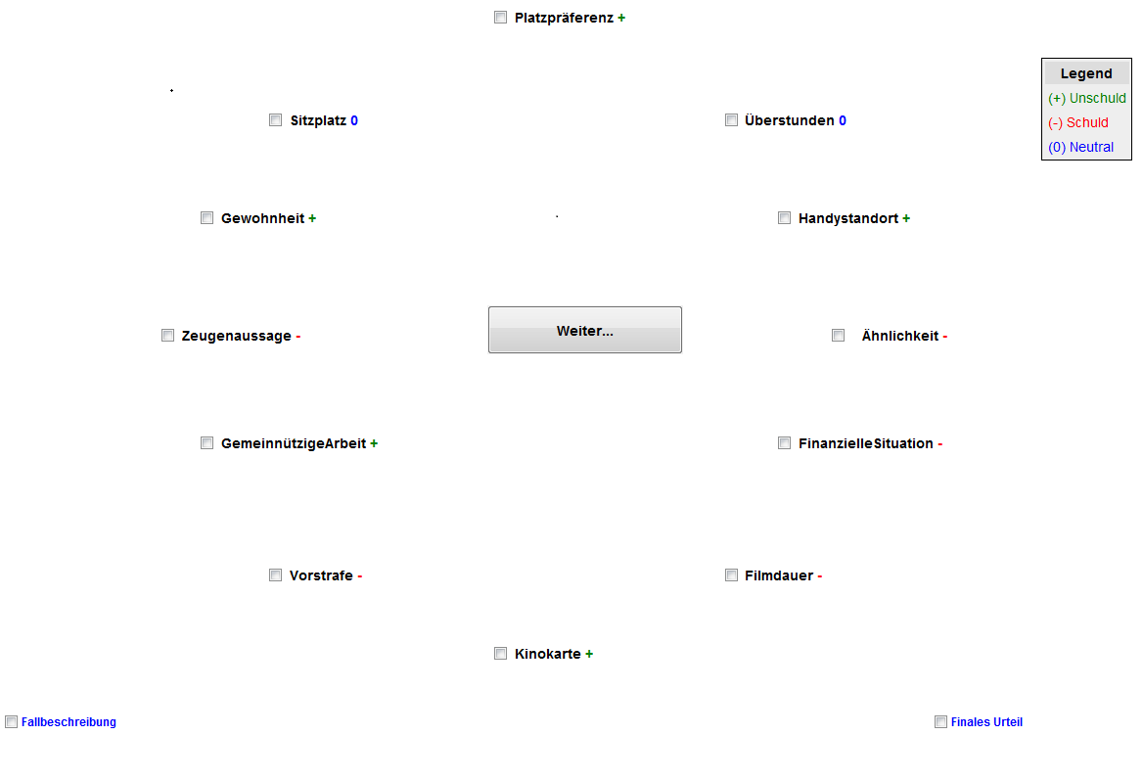
Figure 1. Circular display of evidence. In order to analyze the information search, the pieces of evidence were equally spaced around a “continue button” that participants clicked on after selecting one piece of evidence in order to see its whole content. In the condition that enables a strategic information search, the colored legend describes the valence of the evidence (pro guilt / innocence or neutral).

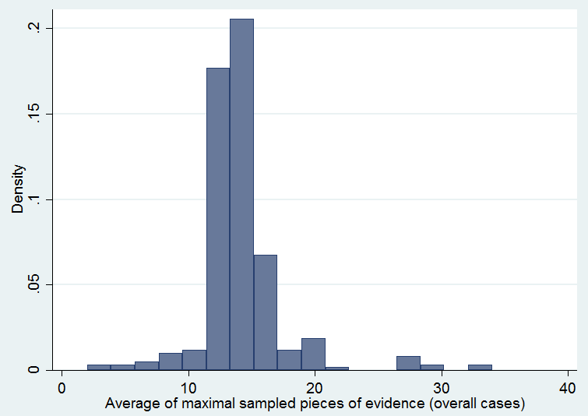
Figure 2. Participants on average searched for complete information before making the final verdict.
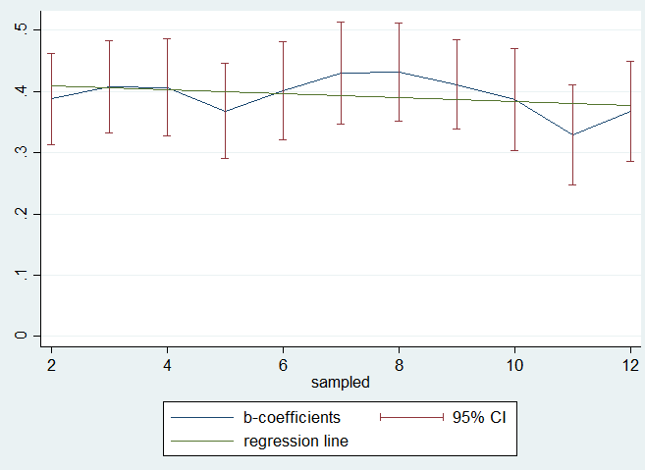
Figure 3. Coherence Shifts are similar in each part of the information sampling process and differ significantly from zero.
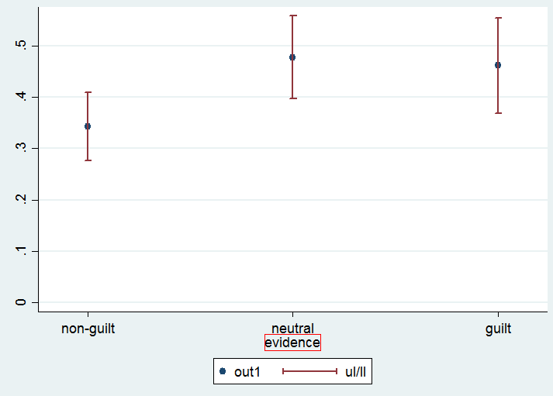
Figure 4. Coherence Shifts dependent on the valence of the evidence.

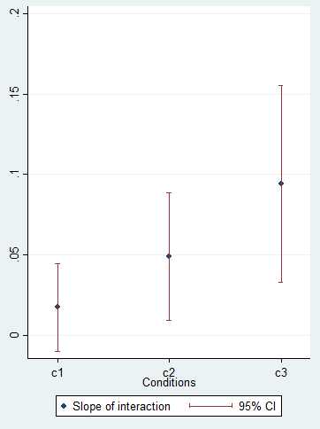
Figure 5. Interaction of Coherence Shifts and information search. The slopes of coherence shifts are significantly different from zero in the systematic search conditions (C2 and C3).

Within the legal context, coherence shifts are also known as predecisional distortion (Carlson & Russo, 2001).Carlson, K. A., & Russo, J. E. (2001). Biased interpretation of evidence by mock jurors. Journal of Experimental Psychology: Applied, 7(2), 91.
We excluded N = 10 participants in studies 1 to 3 due to a lack of language abilities. Furthermore, 6 participants were excluded from analysis in the online study 4, due to insufficient conscientiousness in the handling of the studies (making the final verdict without regarding any of the evidence material). To include them would unsystematically change the results in the single studies but does not change the results of the overall analysis.
Results of the personality factors were inconclusive and will be reported in the appendix.
As participants are not likely to sample pieces of information twice, the information search in this paradigm can be understood as an urn model from which participants sample without replacement. Therefore, the probability to pick a confirmatory piece of evidence is reduced over the sampling process.

